# PRESENT EDUCATIONAL SYSTEM

*“We live in a society where teachers destroy creativity and parents destroy inner strength of children “*

Hope the above statement makes your mind awake in the way of anger or happy. But it’s true that we are living in a society where there are 1.5 million schools and about 260 million students where only 60 million students are achieving their goal and remaining are living their lives in a dead body manner. The above statements may be cruel but they are facts. India is the second largest school system in the world but we are the first largest country in producing slaves. It’s true that we are first in producing labor for many companies but we are not capable of making a own company this is true and remains true due to our educational system.

Our educational system is the only system where we are teaching our children that creativity is important by words but not in action. The persons who are implementing their creativity will be treated as illiterate and they remain to be illiterate and their creativity is destroyed from the childhood. When we go to the ancient culture of educational system where children used to go to gurukul and learn. That was the time when India was leading all the countries in the view of educational system and economy. There is a famous statement by British governor during the visit to India where he states “By changing the educational system we can produce many labors in India”. This was made true by their actions.

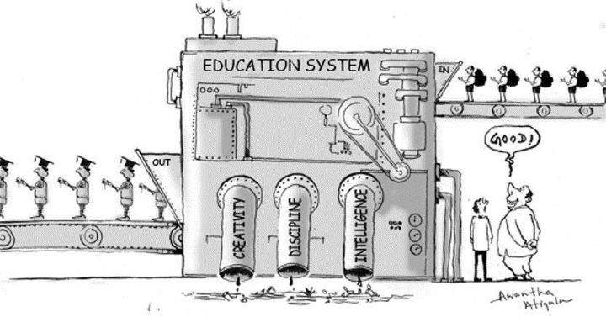

Our present educational system resembles the old system implemented by British rule but the British and many other countries are following the olden Indian educational system which resembles gurukuls. But why?

## Why our country is not having the ignited minds even having the second largest school system in the world?

The answer is so simple… the blog is the answer. We are having 246 BAL Gurukuls at present in India and the students who studied in the gurukuls have succeeded in their life by achieving their goals. But you can ask me why those students have not established a company or bring the higher economy. It’s because of the society we are living. Parents believe that their children are talented by studying in universities and colleges where they destroy the creativity of children and destroy their dreams. We strongly believe that the people who got more marks or percentage is talented and who failed in exams are useless. This is the main reason that every month nearly 28 students are committing suicide every day. We cannot change the world until we change our mindset. Just think how you can get same fruit from different seeds, this is what we are expecting from our colleges and schools.

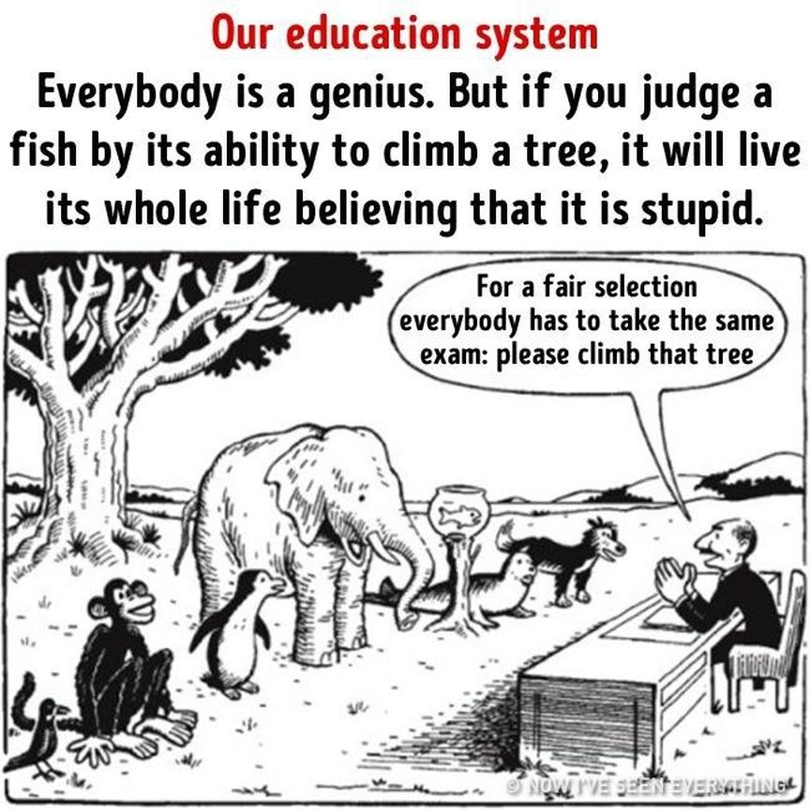

How many of you knew that exams were discovered as a punishment to the children. But we made exams as mandatory and talent recognizing competition. How can punishments discover their talents? When it comes to syllabus our colleges and schools are following the outdated syllabus saying it to be the basic but what about the latest developments around the world. Every person has their own talent it is the duty of the teachers and universities to identify their talent and give them training in that particular area. This is the procedure followed by our ancestors and present foreigners which brought a great change in their living system.

It has been common for each and every people to keep status in their social websites when a student commits suicide regarding our educational system and blaming the others but we follow the same foolish steps as a witless. None are the reason but we are the only reason for a child death. Until we change our minds regarding the educational system don’t blame others, blame yourselves. You killed many students with your impolitic behavior and mindset.

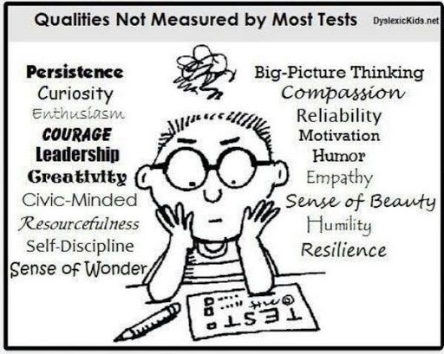

*We think that we have educated our brains but we are nescient by our brain and society.*